**West Virginia University Institute of Technology**

**BIOL-461: Evolution**

**Dr. Jonathan Mitchell**

**April 29, 2022**

**Kayla Canada**

**Examining the Correlation Between Shell Length and Average Size in Testudines**

**Introduction**

The Order Testudines is comprised of the reptilian organisms’ turtles, tortoises, and terrapins. The Testudines order contains over 300 species and 13 families of reptiles, living in different environments all over the world. In this paper we’re going to examine the Family Testudinidae, otherwise known as the Tortoises. The Testudinidae family represents 60 species of tortoises across the world, that can be identified through a variety of features such as shell rigidness, bony plates, and a wide range of body sizes (Dosik & Stayton, 2016). In the paper article “Size, Shape, and Stress in Tortoise Shell Evolution” by Michael Dosik and Tristan Stayton, the coevolution of size, shape, and shell strength. The researchers hypothesized that tortoises were under pressure to evolve the size and strength of their shells depending on their body size (Dosik & Stayton, 2016). The results found that shell size and strength were in correlation to one another, but the data did not support the hypothesis that tortoises were evolving due to body size(Dosik & Stayton, 2016). Although researchers needed more data to support their evolutionary hypothesis, I decided to use the data provided to test my own hypothesis. I hypothesize, that there is a direct positive correlation to shell growth and body mass of a tortoise. In this paper I analyze the correlation between the dependent variable (average shell length) and the independent variable (average weight) in 44 species of tortoise (Dosik & Stayton, 2016).

**Materials and Methods**

**A)** **Data**

The data for this paper was obtained from the research article “Size, Shape, and Stress in Tortoise Shell Evolution” by Michael Dosik and Tristan Stayton. Data of 44 species of Testudines were recorded in an excel spreadsheet with observed recordings of shell length (mm) and average weight (kg) in relation to a specific species of testudines. The observations for each species included multiple measurements for each tortoise observed. For this hypothesis the highest values and lowest values were observed for each species and the average was calculated. This was conducted only for the average shell length of each species which was measured in millimeters (mm). The Encyclopedia of Life (EOL) was also used to determine the average weight measured in grams (*Flat-Backed Spider Tortoise - Encyclopedia of Life*, n.d.). However, for this paper the measurements were converted from grams to kilograms.

**B)**    **Models and Simulations**

A phylogenetic tree was created through the R studio Program to examine the genetic relatedness of each species of tortoise (Figure 1). For this hypothesis, the phylogeny only represents the evolutionary history of Testudines to the Testudinidae Family.

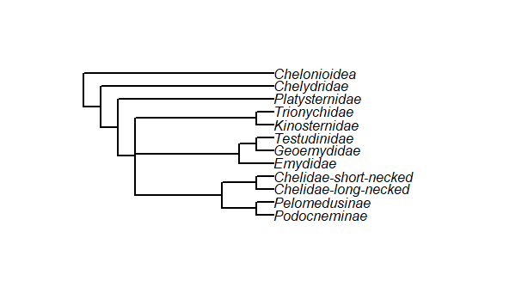

|  |
| --- |
| Figure 1: Phylogenetic Tree that represents the evolutionary descent of Testudines to the Testudinidae Family. |

Simulations were created to analyze the correlation between the average shell length (mm) and average weight (kg) in each species. The first simulation created was a scatterplot that plotted the average shell length (mm) on the Y-axis and the average weight (kg) on the X-axis. Each point of measurement corresponds to a specific species and its observations. Due to the broad range of observations, the data represented on the plot was clustered, making it difficult to interpret. In order to observe the analysis clearly, the logarithmic (log) form of the scales on the axis were taken (Figure 2). Pearson's Correlation was performed to analyze the two variables and determine if the correlation is positive, negative, or zero. The Pearson Correlation is measured on a scale from -1 to +1 with zero representing no correlation between the two variables (Figure 3)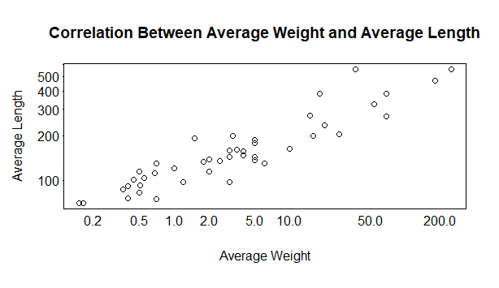

**Results**

The statistical model (Figure 2) below represents the independent and dependent variables in a plotted format.

|  |
| --- |
| Figure 2: Scatterplot that represents the correlation between the Average Weight and Average Length, plotted in logarithmic format. |

The mathematical model (Figure 3) represents the equation used to calculate the correlation coefficient.

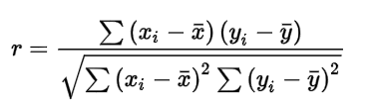

|  |
| --- |
| Figure 2: The Pearson Correlation Coefficient Equation used to determine any correlation between the variables. |

The Pearson Correlation Coefficient measured an r-value of 0.7802651 which is measured on a scale of -1 to +1.

**Discussion**

Figure 2 of the Scatter Plot represents an upward display of the data indicating that the relationship between the Independent and dependent variables. This is confirmed by the results produced from the Pearson Correlation Coefficient, r= 0.7802651. Indicating that statistically the data is positively correlated with an r-value that measures close to +1. Supporting the hypothesis, that in most species of tortoise the length of the shell growth is dependent upon the weight of that tortoise. However it’s important to note, that although the analysis supports the hypothesis, it cannot be said that all species of tortoise have a positive correlation between the two variables. The data represents a few species that were observed having a larger body mass but smaller shell lengths. However, for this analysis and the species of tortoise represented in the data an overall positive correlation was found between the average shell length and average weight.

**Literature Cited**

Dosik, M., & Stayton, T. (2016). Size, Shape, and Stress in Tortoise Shell Evolution. *Herpetologica*, *72*(4), 309–317.

*Figure 1. Phylogenetic relationships of sea turtles...* (n.d.). ResearchGate. Retrieved April 29, 2022, from https://www.researchgate.net/figure/Phylogenetic-relationships-of-sea-turtles-Chelonioidea-The-alternative-positions-of_fig22_233396959

*Flat-backed Spider Tortoise—Encyclopedia of Life*. (n.d.). Retrieved April 29, 2022, from https://eol.org/pages/1055444

*THE REPTILE DATABASE*. (n.d.). Retrieved April 29, 2022, from http://reptile-database.org/

Wang, E., Donatti, C. I., Ferreira, V. L., Raizer, J., & Himmelstein, J. (2011). Food Habits and Notes on the Biology of Chelonoidis carbonaria (Spix 1824) (Testudinidae, Chelonia) in the Southern Pantanal, Brazil. *South American Journal of Herpetology*, *6*(1), 11–19. https://doi.org/10.2994/057.006.0102